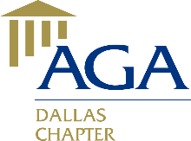*Advancing Government*

*Accountability in Dallas*

### January 2014 Lunch Meeting

The HHS Division of Cost Allocation (DCA) represents the entire Federal government when negotiating rates and cost allocation plans. During fiscal year 2013, DCA negotiated and issued approximately 2,700 Rate Agreements that resulted in cost avoidance of $700 million and more than $90 million in cash refunds. DCA services at least 80 to 90 percent of the colleges and universities in the U.S. Through an Interagency Agreement, DCA also provides negotiation services to non-HHS customers, such as HUD, DOT, FEMA, and USDA.

**Date/Time**: January 16, 2014, from 11:30 a.m. – 1:00 p.m.

**Speaker:** Arif “Mak” Karim, Director, HHS DCA

**Topic**: An Overview of the Health and Human Services – Division of Cost Allocation and its Mission

**Place:** City Club (69th Floor), Bank of America Plaza, 901 Main Street, Dallas

**Parking:** The Texas Club Garage (across the street from the Bank of America Plaza)

**Cost:** $15 for AGA members, $24 for non-AGA members

**RSVP:** Please RSVP by Tuesday, January 14, 2014, to Lisa Lara at [meetings_socials@agadallas.org](mailto:meetings_socials@agadallas.org)

**Earn 1 CPE!** The AGA Dallas Chapter is committed to providing quality educational events for its members. All AGA Dallas meetings and training events are catered to the beginner to intermediate skill level; no advance preparation or prerequisites are needed.

**Speaker’s biography**

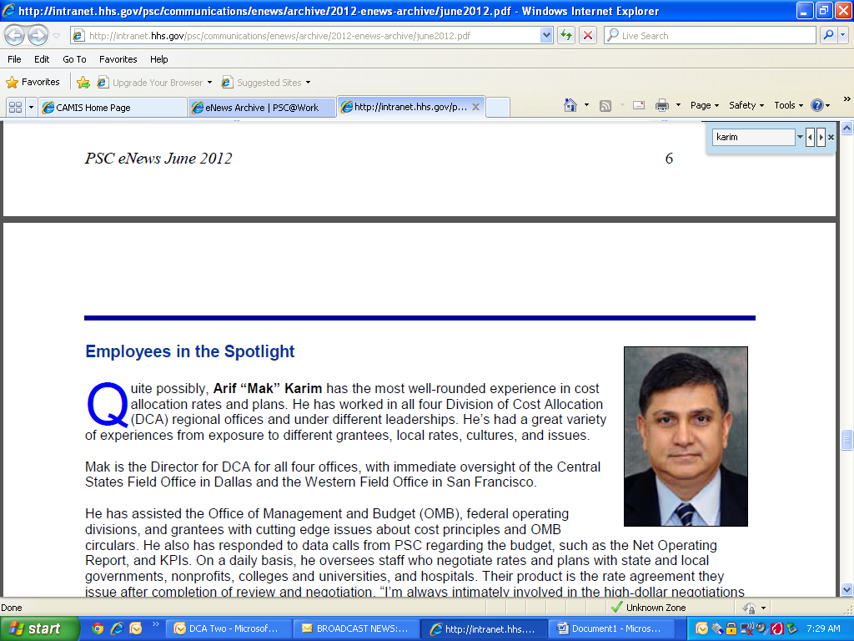Effective January 2010, Arif “Mak” Karim became the Director of the Division of Cost Allocation (DCA). Arif began his Federal career in DCA’s Northeast Field office as a cost allocation specialist in 1990. He relocated to DCA headquarters in Washington D.C. in fall of 1999, and was subsequently promoted to branch chief for colleges/universities, non-profits and hospitals. He transitioned to DCA’s Central States Field Office in Dallas in the summer of 2009 where he was promoted to Director, Division of Cost Allocation. In his current capacity as director, he oversees all four DCA offices (New York, San Francisco, Bethesda and Dallas) staff and operations.

Mr. Karim has assisted Office of Management & Budget (OMB) on many occasions in policy matters, recently as part of the task force known as Council on Financial Assistance Reform (COFAR) – in the recent publication of new OMNI Circular. In addition, even though DCA is strictly operations, he has assisted the Department of Health and Human Services (DHHS) on cutting edge policy issues.

Mr. Karim received his Bachelor of Science degree in Accounting from the State University of New York, College at Old Westbury. His office is located in the Central States Region in Dallas.