*Advancing Government*

*Accountability in Dallas*

### November 2013 Lunch Meeting

Your health care provider may be moving from paper records to electronic health records (EHRs) or may be using EHRs already. However, EHRs will not change the privacy protections or security safeguards that apply to your health information. By enforcing the Privacy and Security Rules, the HHS Office of Civil Rights (OCR) helps to protect the privacy of your health information. Come find out how!

The presentation will cover general background on the OCR and a discussion of the laws enforced by OCR.  These laws include traditional Civil Rights laws as well as the Health Insurance Portability and Accountability Act (HIPAA) Privacy Rule.

**Date/Time**: November 21, 2013, from 11:30 a.m. – 1:00 p.m.

**Speaker:** Jorge A. Lozano, Dallas Regional Manager, HHS Office for Civil Rights

**Topic**: An Overview of the Health and Human Services – Office for Civil Rights

**Place:** City Club (69th Floor), Bank of America Plaza, 901 Main Street, Dallas

**Parking:** The Texas Club Garage (across the street from the Bank of America Plaza)

**Cost:** $15 for AGA members, $24 for non-AGA members

**Menu:** Poblano Pepper Soup, Beef Tenderloin tips w/ onions, mushrooms & rice pilaf, crème brulee w/ chocolate chips

**RSVP:** Please RSVP by Tuesday, November 19, 2013, to Lisa Lara at [meetings_socials@agadallas.org](mailto:meetings_socials@agadallas.org)

**Earn 1 CPE!** The AGA Dallas Chapter is committed to providing quality educational events for its members. All AGA Dallas meetings and training events are catered to the beginner to intermediate skill level; no advance preparation or prerequisites are needed.

**Speaker’s biography**

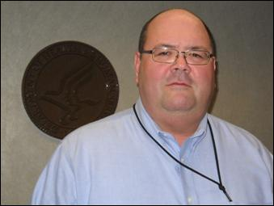Effective February 4, 2013 **Jorge Lozano** became the HHS, OCR Region VI, Regional Manager.  Jorge began his public service career with the Kansas Advisory Committee on Hispanic Affairs, where he was the staff person in charge of programming, public relations, and small business development programs.  Afterward, Jorge moved into health insurance regulation working for the Kansas and Colorado Insurance Departments. Jorge's tenure at HHS began in 1997 when he joined the Kansas City Regional Office of HCFA (now CMS) to enforce the health insurance reform provisions of HIPAA Title I and its amendments.  While at CMS, Jorge was detailed to CMS headquarters to participate in the development and authorship of the HIPAA Title I enforcement regulations.

 In 2005, Jorge moved over to OCR to work as Region VII’s Privacy Rule Team Leader.  Just three years later, Jorge became Deputy Regional Manager for OCR Region VII and subsequently, from July to October 2012, Jorge assumed the role of acting OCR Regional Manager.  Jorge graduated Magna Cum Laude from Washburn University with a dual major of Marketing and Management.