July 30, 2026

Gabe Stafford
Des Moines AGA Chapter
2925 Woodland Avenue, #210
Des Moines, Iowa 50312

Dear Gabe:

AGA applauds your commitment to good governance and responsible fiscal action reflected in the FY 2014 Des Moines Chapter CCR. The purpose for doing the report is to inform your members of how the chapter is doing and to use as a marketing tool when recruiting new members.

As part of AGA’s Citizen-Centric Reporting award program, I’m pleased to present you with a Certificate of Excellence in Citizen-Centric Reporting.

The team would like to commend you on the outstanding points of your report:
- Visual Appeal – The report is visually attractive and inviting. The report was nicely
designed and the imagery added character to the report. This is a model chapter
CCR!
- Performance Measures – This is an excellent description of the performance
measures and comparing prior year results with targets and actual results for the
current year. Identifying how to get more information is an added plus. Great job!
- Finances – This page shows that the preparer has gone to great lengths to describe
the chapter finances.

As with any report, there are opportunities for growth. Here are some items that the review team would like to see improved for your next report:

- Page 1 – Consider less text and include a picture of a chapter activity.
- Page 2 – No recommendations.
- Page 3 – No recommendations.
- Page 4 – Consider titling this page “Challenges” and identify specific resolution activities, i.e., reimburse members who receive their CGFM, prepare a CCR for a local entity or agency, etc.

AGA members believe that government accountability and transparency are essential to a healthy democracy and are committed to fulfilling our obligation to advance government accountability. By preparing a Citizen-Centric Report for your chapter, you have taken the first step to understanding this initiative and giving yourself an informed platform on which to stand and promote the report.

Again, congratulations on your noteworthy accomplishment. We’re counting on your support to ensure that our important work continues well into the future. We look forward to seeing your future reports!

Sincerely,
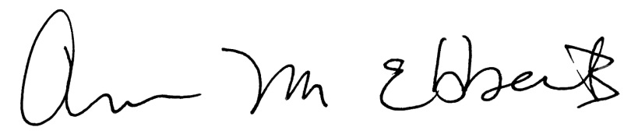

Ann M. Ebberts, MS, PMP
Chief Executive Officer

Enclosure

