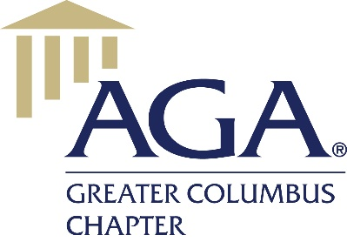**The Association of Government Accountants (AGA)** is a non-profit organization for financial professionals in government. AGA extends membership opportunity to government, private sector, and academic professionals in the government financial management community. The majority of members of the approximately 100 members of the **Greater Columbus Chapter** (established 2004) are federal employees and work for Defense Finance & Accounting Service (DFAS), but there are non-DFAS members as well. Membership consists of accountants, accounting technicians, auditors, systems personnel, project managers, and more. Our mission is to foster learning, certification, leadership, and collaboration for professionals and stakeholders committed to advancing government accountability.

The chapter primarily offers **educational, networking, and community service events**. Educational events include luncheons or webinars, are held most months at DFAS Columbus Building 21, and typically offer CPE. The chapter hosts two yearly professional development training events, averaging around 100 attendees, as well as an annual Professional Fair, often partnering with the local Buckeye Chapter of ASMC (American Society of Military Comptrollers). The chapter supports members obtaining the **Certified Government Financial Management (CGFM) designation**, which is the premiere certification for financial managers across government. Our members are involved in community service events like Toys for Tots and Volunteer Income Tax Assistance (VITA), and the chapter annually provides two scholarships for deserving students pursuing a financial management degree. Lastly, the chapter holds several social events throughout the year providing the opportunity for members to connect.

|  |  |
| --- | --- |
| **Greater Columbus AGA Membership Statistics – as of July 2017** | |
| **Job Area** | **Employer** |
| **Accounting 56%**  **Auditing 12%**  **Financial Management 6%**  **Information Systems 3%**  **Management/Administration 3%**  **Budgeting 2%**  **Consulting 2%**  **Other 16%** | **Federal Government 74%**  **State Government 11%**  **Local Government 6%**  **County Government 1%**  **Private Sector 5%**  **Academic Sector – 2%**  **Retired – 1%** |
| **Membership Growth** | |
| **July 2015 – 79 Members**  **July 2016 – 89 Members**  **July 2017 – 99 Members** | |