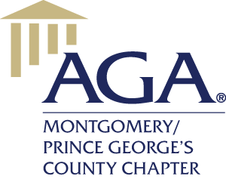

**ATTENTION FUTURE ACCOUNTANTS!!!!!!!!!!!**

# We invite all students in Maryland to participate in the…

Montgomery/Prince George’s County Chapter of the Association of Government Accountants (AGA) Citizen-Centric Report Contest for a chance to win **$2,000**!

What is the Citizen‐Centric Report Contest?

Learn more about your state or local government and have the chance to be awarded a cash prize. The Montgomery/Prince George’s County Chapter of the AGA is hosting its annual contest for teams of college students to create a Citizen‐Centric Report (CCR) on a governmental entity in Maryland. AGA's Citizen‐Centric Government Reporting Initiative is intended to foster innovative means of communication between governments and their citizenry. AGA believes that government financial information should be provided to citizens in forms that are clear and understandable, updated regularly and often, delivered to all, easy to locate, honest in breadth and technically accurate in detail. In fact, as the owners of government, citizens have a right to this information.

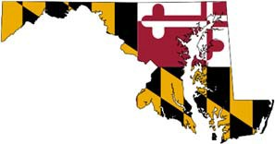

# Contest details:

* Teams must include 2‐4 students and may select any governmental entity in Maryland (e.g., State of Maryland, Montgomery County, Prince George’s County).
* Teams must register by **March 1, 2021** via email to accountability@marylandaga.com; providing the school, names of team members, and the governmental entity selected.
* AGA National’s website has many resources to assist with the preparation of a CCR, including a variety of templates. You can find this information online at [http://www.agacgfm.org/citizen/.](http://www.agacgfm.org/citizen/)
* Teams must submit their CCRs by **March 31, 2021**. Early submission is encouraged!
* Finalists will present their CCRs at a Montgomery/Prince George’s County AGA Chapter dinner meeting. Please plan on having at least one team member attend the dinner, which may be in a virtual environment. These meetings also offer a great networking opportunity with local professionals.
* The winning team will be announced in **May 2021** and will be awarded a **$2,000 cash prize** evenly divided among the team members.

Any questions about this contest can be directed to [accountability@marylandaga.com.](mailto:accountability@marylandaga.com)