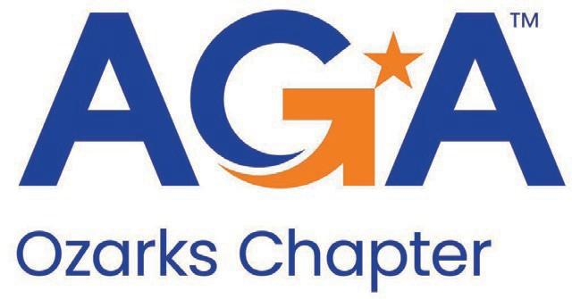

AGA CEC Meeting

November 14, 2024

1. Call to Order

The Meeting was called to order at 12:00 pm.

1. Attendees

Monica Robinson, Tona Bowen, Yan Gao, Sarah Burrows, Teresa Allen, Candace Grossman, Leslie Forest, Allen Criger, Carmen Todea, Debbie Parks, Kyle Goodin, Debi Phelps

1. Opening Comments
   1. Approved 10/10/2024 Meeting Minutes without updates.
2. Treasurer Report – Yan Gao
   1. Motion to Approve November Reports was made by Tona Bowen and seconded by Teresa Allen.
      1. Motion Approved.
3. Update

a. Need to review By-Laws at a future meeting. Motion to approve topic - Sarah Burrows, Carmen Todea second. All approved

b. Need to discuss further topics for spring seminar.

1. Educational Events
2. Spring Seminar
   1. Going to request someone from MSU speak
3. Latte & Learn - needing to confirm the speaker. Ozark or Nixa Attorney??? has it been confirmed
4. Membership
5. Accountability
6. Early Careers
7. Adjournment

Meeting adjourned at 12:35pm.