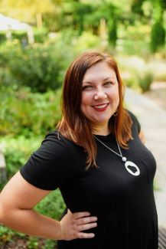

Amanda Day, GPC is a former municipal grants administrator turned consultant with 20 years’ experience in the field. During her 12-year tenure with the City of Alpharetta, she researched funding opportunities, wrote successful proposals, helped create grant policies and systems, and managed a multi-million dollar grant portfolio. Together, with assistance from the finance department, she cleaned up an OIG audit. She is a national trainer for Grant Writing USA. Amanda is the cohost of Fundraising HayDay, a podcast about grants and such. She currently serves as President of the Grant Professionals Association. She previously served as President of the Grants Professionals Certification Institute. She’s a total book nerd and grant geek. You can connect with her at [amandadaygpc@gmail.com](mailto:amandadaygpc@gmail.com) or on Twitter at @wholewheatgirl.