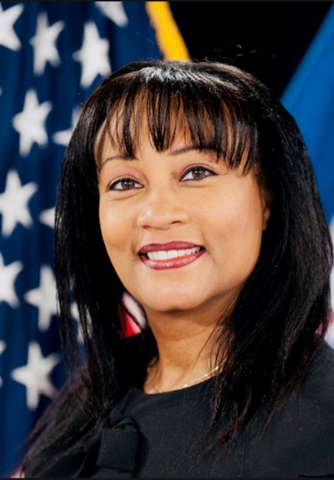
Andrea Brandon, MLS, MPA, Deputy Assistant Secretary for Budget, Finance, Grants & Acquistion, Dept. of Interior

Ms. Andrea Brandon is currently the Deputy Assistant Secretary (DAS) for Budget, Finance, Grants and Acquisition within the Department of Interior (DOI). As the DAS she has executive responsibility for the leadership and strategic direction of all budget, finance, financial assistance, acquisitions, property, and related business IT systems for the DOI. This portfolio comprises of more than $5.3 B. Ms. Brandon has held similar positions in DHS and HHS. She has had broad experience in risk management, audits, internal controls, information technology innovation, acquisition management, and financial operations in her federal career of 30 years.

