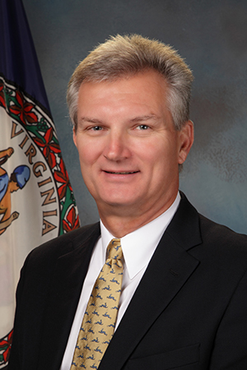

**Secretary Aubrey Layne, Virginia Secretary of Finance**

Aubrey L. Layne, Jr. serves as the Secretary of Finance in Governor Ralph S. Northam’s administration. Having taken his oath of office on January 14, 2018, he currently oversees the four main finance agencies in the Commonwealth of Virginia: Department of Accounts; Department of Planning and Budget; Department of Taxation; and Department of the Treasury – along with the Virginia Resources Authority and the Virginia Board of Accountancy. Previously, Governor Terence R. McAuliffe appointed Mr. Layne as Secretary of Transportation for the Commonwealth of Virginia – he served in this capacity from January 2014 - January 2018. As the Secretary of Transportation, he oversaw seven agencies with over 10,000 employees and combined budgets of more than $6 billion. Prior to his appointment, he represented the Hampton Roads area on the Commonwealth Transportation Board from 2006 until January 2014. Before his service to the Commonwealth of Virginia, Mr. Layne most recently served as President of An Achievable Dream Academy in Newport News, Virginia, a unique partnership between Newport News Public Schools, the City of Newport News and the local business community to give students who are at risk of failure in school due to socioeconomic factors, a chance to succeed.   
Also, Mr. Layne has served as President and Principal Broker of Great Atlantic Properties; he joined the company in 1994 and was responsible for operational activities, new business acquisition, and capital improvement strategy. Prior to joining Great Atlantic, he has held various positions at Hofheimer’s Inc., and ended his tenure there as President. Mr. Layne began his career as a Certified Public Accountant with KPMG. Mr. Layne earned a B.S. in Accounting from the University of Richmond and received an MBA from Old Dominion University with a concentration in International Business. In 2011, he completed the University of Virginia’s Sorensen Institute for Political Leaders program. Secretary Layne and his wife, Peggy, reside in Richmond, Virginia.