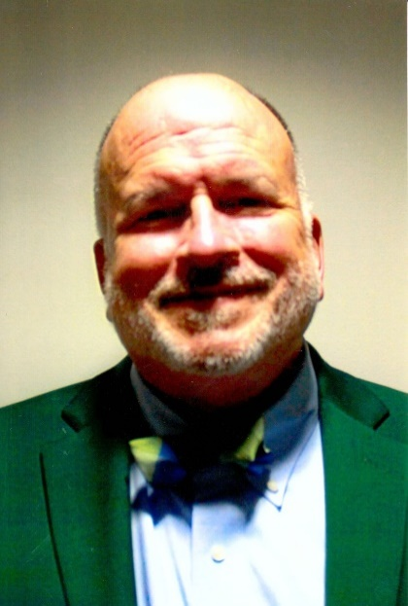

**Dr. Douglas Ziegenfuss, ODU Associate Professor and Chair, Accounting Department**

Dr. Ziegenfuss is a long time supporter of professsional associations, including the AGA, and holds most, if not all, of the recognized certifications within our professional. He has a BA from Mount Saint Mary's, and MS from American University and a PHD from VCU.