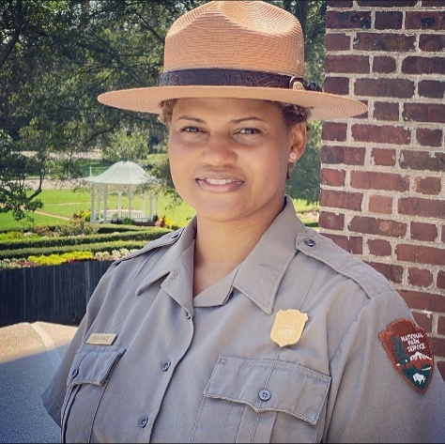

Eola L. Dance, Superintendent (Acting), Fort Monroe National Monument

Eola Dance is currently the Acting Superintendent at Fort Monroe National Monument in Hampton, VA. Eola normally serves as the Supervisory of Resources Stewardship and Science at Colonial National Historical Park, formerly the National Capital Area Regional Ethnographer, Eola is a 19 years career National Park Service employee. Having begun her career with the NPS as an interpretive park ranger at the Frederick Douglass National Historic Site in 2001, Eola served a stint as a supervisory ranger at Maggie L. Walker National Historic Site, then as cultural anthropologist at National Capital Parks East. Specializing in the coordination of interdisciplinary teams, community engagement, and program management Eola has incorporated the importance of soft skills into management, recruitment, development and retention of top performers and fostering dynamic teams. Eola is currently a third year doctoral student at Howard University in the History Program with a focus on the Colonial Era, women's history and African American Experience, and Museums.

