**Biography**

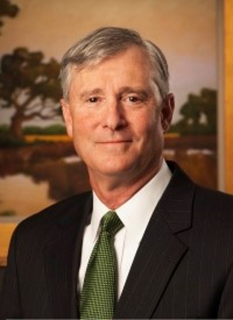

Paul is as Portfolio Manager for Wilbanks Smith & Thomas, a Norfolk based financial adviser. WS&T was recently recognized by the leading business channel CNBC as one of the top 100 Registered Investment Advisors in the country.

Paul graduated from Auburn University with a B.A. in Finance and earned an M.B.A. from Duke University. He is a Chartered Financial Analyst and a member of CFA Society Virginia.

Paul has extensive public speaking experience over his 38 year career and has presented to a wide variety of audiences and thousands of people around the country. He believes in adding value to a subject in a thought provoking and entertaining manner using everyday examples to explain financial market complexities and the influence of cognitive biases in decision making.

His current topic is “Five Tips for Better Decisions in a Connected World.” Paul has presented or is scheduled to present for continuing education credit to chapters of the Virginia Society of CPAs (VSCPA), the Estate Planning Council (EPC), the Association of Government Accountants (AGA), the Healthcare Financial Management Association (HFMA), The Florida Institute of CPAs (FICPA), the Society of Human Resource Management (SHRM) and the American College of Healthcare Executives (ACHE). Non educational presentations include the American Association of Individual Investors and the Palm Beach Round Table.