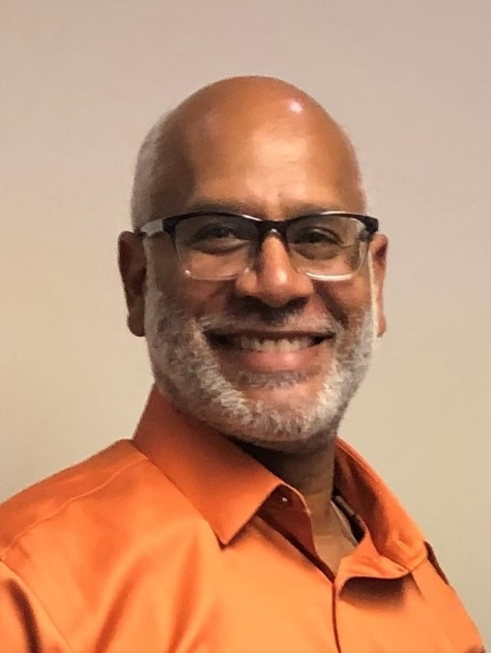

Frank Jones, CIA
Management Analyst
Treasury Inspector General for Tax Administration
Atlanta, GA (770) 617-6433
Frank.Jones@tigta.treas.gov

Frank Jones currently serves as a Management Analyst with the Treasury Inspector General for Tax Administration (TIGTA) in Atlanta, GA. Frank previously served as an Audit Manager in the Returns Processing and Account Service program and as an Audit Director in the Compliance and Enforcement Operations Program. His auditable areas included IRS's Small Business/Self Employed and Wage and Investment Income Operating Divisions functional offices that include Examination, Collection, Criminal Investigation, Office of Professional Responsibility, Field Assistance, Electronic Tax Administration, Media and Publications, and Stakeholder, Partnership, Education and Communication. Frank has served as a Council of Inspectors General on Integrity and Efficiency (CIGIE) instructor since 2009 and also serves as an auditing instructor for TIGTA.
Frank began his career with the IRS Inspection Service in 1989, and has been with TIGTA since its establishment in 1998. While with TIGTA, he has participated in several notable customer service reviews where Frank and his team have played the role of taxpayers and conducted anonymous visits to IRS Taxpayer Assistance Centers and Volunteer Income Tax Assistance sites. For this review, auditors evaluated IRS employees and volunteers’ ability to correctly answer tax law questions and prepare accurate tax returns. During the 2008 filing season, Frank expanded his efforts and his team conducted anonymous visits to unenrolled commercial tax return preparation companies. The results from these reviews were instrumental in the IRS establishing the Taxpayer Assistance Blueprint and Paid Preparer Strategy.
Frank has received a CIGIE award for innovative customer service reviews and an IG Award for TIGTA receiving NASBA accreditation “group live” and “Internet-based” training. In 2016 Frank also received the inaugural Adjunct Instructor Training Award of Excellence from CIGIE. With more than 31 years of auditing experience, Frank’s unique blend of high energy and positive outlook on life makes his presentations motivational, leaving class participants excited and enthusiastic about the auditing profession. His educational mission is to inspire all students to go from being good to great auditors.

Frank has a BA in Accounting and Finance from Loyola University in New Orleans, Louisiana, and is a Certified Internal Auditor. Frank lives in Stone Mountain, GA with his wife Lori. In his free time, Frank enjoys coaching basketball, reading, playing on-line chess and spending time with his family.

