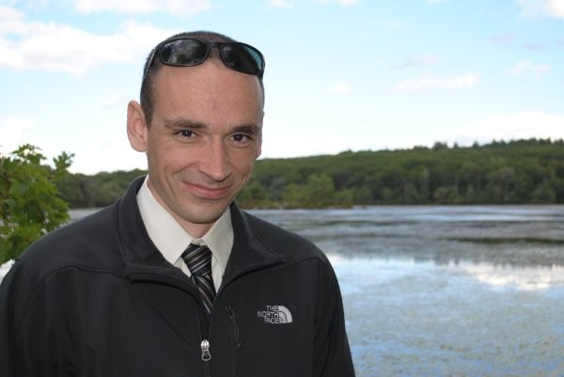

**Jason Jones, Trial Attorney, US DOJ**

Jason Jones has been a trial attorney with the Antitrust Division for 10 years.  He has prosecuted various domestic and international antitrust cartel conspiracies from the international auto parts industry to regional real estate foreclosure auctions.  Jason also advises the Division on developments in electronic evidence gathering techniques.  He has also worked at the United States Attorney’s Office for the Southern District of California and the Eastern District of Virginia.