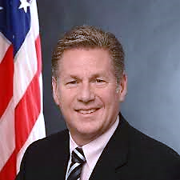

**Michael Peckham, BS, ICAgile Certified Professional, Acting CFO for HHS Program Support Center & ReInvent Grants Management Lead for Department-wide ReImagine Health and Human Services**

Michael Peckham is the Acting CFO of the HHS Program Support Center. Most recently he led the ReInvent Grants Management transformation initiative under the HHS ReImagine program. Mike also led the HHS DATA Act initiatives in successfully meeting the implementation goals as well as the grants pilot required under section 5 of the statute. He brings over 30 years of broad experience leading HHS in meeting its administrative modernization and shared services goals. He is a champion for positive change, creating new approaches to old problems through Human Center Design, Agile methodologies, microservices architecture, and applying emerging technology to promote data driven business decisions.