**Tyler Gall, CPA, CISA, CFE**

**Senior Associate**

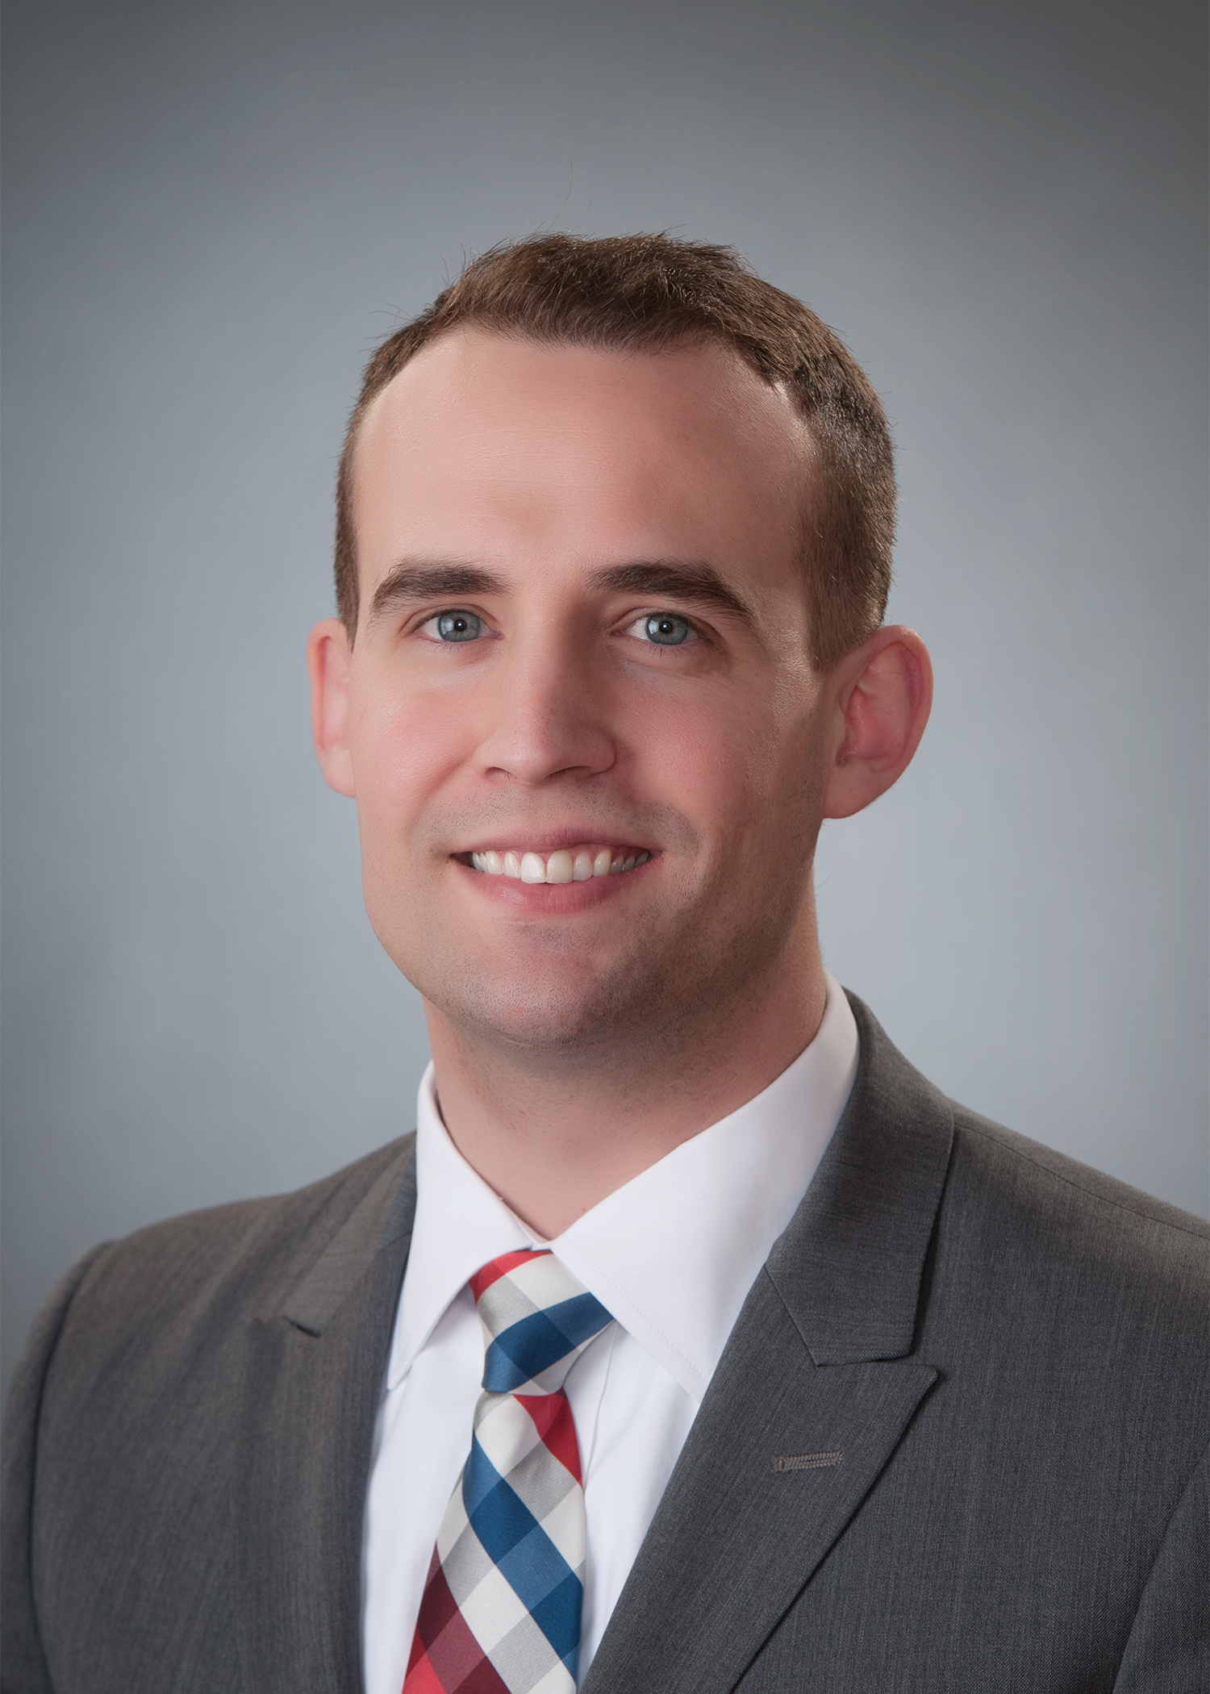

Tyler works in IT assurance for the various clients we serve. Tyler has performed various IT audits and assessments related to IT controls across various industries. Tyler has over 7 years of experience as an auditor. Before joining Brown Edwards in April of 2019, Tyler primarily focused on financial and performance audits of large government entities. Tyler led audits for an Inspector General office to assist in the preventing and detecting of fraud, waste, and abuse. Also, Tyler has assisted on various consulting engagements focusing on the development of indirect cost rates and data reliability.

**PROFESSIONAL AFFILIATIONS**

American Institute of Certified Public Accountants

Association of Certified Fraud Examiners

**EDUCATION**

B.S., Accounting and Finance, Radford University

**Expertise and Experience**

* Performed IT Assessments, IT audits, and IT risk assessments
* Performed various audits over internal control compliance with standards
* Functioned as the lead auditor for financial audits and performance audits of various entities and programs