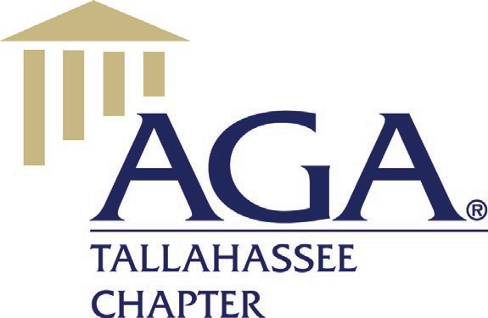

# Tuesday, November 9, 5:30 PM Chapter Executive Committee Meeting

Virtual Zoom, Tallahassee, Florida

# MINUTES

**Call to Order** – President Patricia Manning called the meeting to order at 5:37 pm. The following officers and directors were in Virtual “Zoom” attendance:

Chapter Officers:

Patricia Manning, President

Pete Walker, Treasurer

Antonio Murphy, Treasurer-Elect

Pamela Ray, Secretary

Board Members:

Tracie Hodge, President-Elect

Alexandra Weimorts

Angie Robertson

Patrick Cowen

Brittnee Clark

Angela Rowe

Justin Evans

Officers and Directors not present:

Sue Graham

Melinda Miquel

Wicliff Fleurizard

**Meeting Called to Order** – President Patricia Manning welcomed the officers and directors to the meeting.

**Meeting Quorum** – Pam Ray indicated a quorum was present. A quorum is reached when 50% plus 1 are in attendance.

**Prior Meeting Minutes** – Pam Ray circulated the minutes and corrections were made. Angie Robertson made a motion to accept the minutes and Pete Walker seconded. The minutes were voted and approved unanimously.

# New Business:

# Community Service

# Patricia Manning suggested that we continue with the Wreaths Across America and purchasing 10 wreaths as in the past. No motion was needed since it is already in the budget so she will move forward with this purchase. She also suggested donating to Ronald McDonald House and Elder Care Services.

# November 17, 2021 – Monthly Luncheon

# Patricia Manning notified the committee that Matthew Tracy will be presenting the Florida Auditor General Update. There are currently 28 registered to attend with 16 in-person, including the speaker. Registration ends 11/11/21 with the head count due to the country club by 11/12/21. Another announcement will go out today or tomorrow. Patricia will be out that day and requested assistance to host. She offered to come early and set-up but is unable to stay. Pam Ray, Angie Rowe, and Pete Walker all responded that they will not be attendance that day. Antonio Murphy will be contacted to see if he can cover the registration desk in Pete’s absence. Since Sue Graham has registered, Patricia offered to touch base with Sue to see if she would be willing to host.

# Status of invoice to Debra Arrant for November Luncheon

# Ms. Arrant registered for the luncheon as a member but is not a member. Patricia asked Pete Walker to invoice Ms. Arrant for the difference in the fee of $5.

# Purchase Order for Membership Dues for Jorge Guzman-Perez (FAMU)

# Patricia received a purchase order for dues for Mr. Perez and asked Pete if he had received one as well. Not sure if it was sent to the AGA National. Patricia will check with National to see if they received the application and not the payment. If so, then AGA Tallahassee will issue a check.

# January 19, 2022 – Monthly Luncheon

# Lillian Spell will be presenting on the topic “Agile Auditing” and would like to present virtually versus in person. Pam indicated that she did not see any problem. Justin agreed. Angie Roberson asked about logistical issues and Patricia confirmed that the speaker could project from her off-site location. Patricia agreed to get the registration information sent out.

# Policies and Procedures and Annual Bylaws Review

# Patricia asked for Justin Evans to give an update on the committee’s progress. Justin replied that little had been done due to other pressing issues at work but will reach out to Melinda tomorrow to schedule some time to get started. Volunteers are welcome to help with review.

# GTE Presenters and Advertisement Update

# Patricia indicated that Tracey Walker has agreed to present in a one-hour slot on the first day, February 10th, but will have to fly out that same day. Alexandra Weimorts will begin sending out emails tomorrow to get speakers slotted. The email template from last year will be utilized with new information about the preference to present in-person with flexibility for virtual if needed. Patricia confirmed that Joe Maleszewski has agreed to present, and Patrick Cowen agreed to reach out to the AGA National President, Gerry Boaz. Alexandra received Patrick’s file format for the presenters and slides for upload to the app tool. The announcement and registration information will go out in December with sufficient time for early bird savings. Angie Rowe, Angie Robertson and Patricia offered to help Alexandra with out-reach to lock in speakers and Alexandra agreed to share/publish the list with all in attendance at this meeting in order to divide and conquer.

# Alexandra asked about whether the caterer had been contacted. Blue Waters was used in the past and Justin offered to contact them to see if they are available and to obtain preliminary pricing for 200 attendees.

# Pam offered to take the lead on out-reach to the GTE sponsors. Patricia offered to reach out to WorkDay and Williams and Fudge. Pete Walker asked about pricing and whether reaching out to competitors will be an issue. Patricia did not foresee any issue. Finally, an invoice will need to be created and Pete agreed to check into it.

# The FSU contract for the Turnbull Center has been signed.

# Old Business:

# Star Chapter

# Alexandra made outreach to the Mid Missouri Chapter and although they responded about assigning the call to a member of their team, they did not get back with Alexandra. Pam recommended that we pass on the product at this time and continue to utilize Constant Contact with their updated website and service. Patricia indicated that Constant Contact had sent an email about an increase in prices beginning November 1st and Patricia asked Pete Walker to follow up with them to see what the changes are.

# Committee Reports:

# Membership

# Sue Graham was not in attendance.

# Finance Committee

# No financials were presented for October. Pete Walker stated that the IRS Form 990 has been completed and Angie Robertson is reviewing for submission which is due on November 15th.

# No Committee Reports Requested

* Awards
* Records Management
* Early Careers/Student Membership
* Education
* Bylaws
* Chapter Recognition Program
* Website/Newsletter

# Other Topics

# Next CEC Meeting

The next CEC meeting will be held December 14, 2021 at 5:30 pm via Zoom.

# Adjournment

There being no further business before the CEC, the meeting was adjourned at 6:18 pm.

Respectfully submitted,

Pamela Ray

Secretary