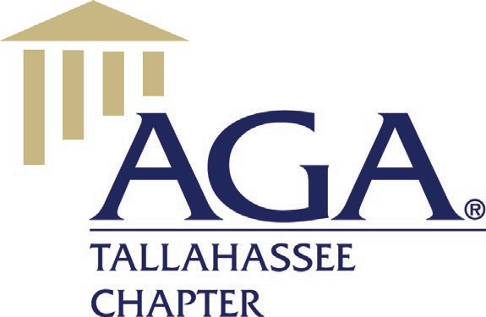

# Tuesday, May 10, 2022, 5:30 PM

# Chapter Executive Committee Meeting

Virtual Zoom, Tallahassee, Florida

# MINUTES

**Call to Order** – President Patricia Manning called the meeting to order at 5:42 pm. The following officers and directors were in Virtual “Zoom” attendance:

Chapter Officers:

Patricia Manning, President

Tracie Hodge, President-Elect

Pete Walker, Treasurer

Pam Ray, Secretary

Board Members:

Angie Robertson

Sue Graham

Justin Evans

Officers and Directors not present:

Antonio Murphy, Treasurer-Elect

Angela Rowe

Patrick Cowen

Alexandra Weimorts

Melinda Miguel

Wicliff Fleurizard

Brittnee Clark

**Meeting Called to Order** – President Patricia Manning welcomed the officers and directors to the meeting. The meeting began at 5:42 pm.

**Meeting Quorum** – Pam Ray indicated a quorum was not present. A quorum is reached when 50% plus 1 are in attendance.

**Prior Meeting Minutes** – There was no CEC meeting in February due to the GTE. The March CEC meeting at the Officers and Directors only luncheon was a recap of the February GTE. No meeting notes were taken.

# New Business:

# AGA Rebranding

# The National Association of Government Accountants is being rebranded to AGA for “Advance, Grow, Accelerate”. The Tallahassee AGA bank records and other documents will be revised later in the summer.

# Annual Membership Satisfaction Survey

# Tracie Hodge prepared the survey and sent to Patricia Manning to review and respond. Once finalized, the survey will be sent to the Chapter members for feedback in order for future planning.

# ACE Update

# The Chapter currently has 4400 points. In order to meet the requirement for platinum, 4700 points are needed. Patricia Manning indicated that once the By-Laws are completed, the Chapter will meet this requirement.

# AGA Webinar May 11

# Patricia confirmed that all 30 slots had been filled with Kimberly Jones registering for the final slot.

# Seeking Board Members

# Brittnee Clark will be taking over the membership responsibilities with Sue Graham remaining on the Board one more year. Sue also offered to assist with the GTE to include communicating and confirming speakers.

# Confirmation of Current Board Members and Officers

# President – Tracie Hodge

# President Elect – TBD

# Secretary and Webmaster – Pam Ray

# Treasurer – Pete Walker

# Treasurer Elect - TDB

# Ethics Training for June

# In order to earn CPE credit, the course must be approved by the Board of Accountancy. The AICPA can give options for a speaker and Sue Graham offered to check on this. Patricia offered to check with the Capital City Country Club as the venue.

# PDT

# Tracie Hodge is scheduled to attend this training in California and Pam Ray also indicated an interest since she was unable to attend in 2020 due to Covid restrictions.

# Nomination for Volunteer of the Year

# This nomination is due to National by 5/31/2. Pam Ray agreed to submit nomination for Alexandra Weimorts.

# NASBA Certification

# AGA National is certified and the discussion followed regarding what AGA Tallahassee needed to do to become certified. If unsuccessful, all training must state the non-certification which could affect the registrants for the GTE.

# Committee Reports:

# Scholarships

# Melinda Miguel edited application and sent to Patricia to review.

# Membership

# Sue Graham reported that the Chapter has 315 members.

# Chapter ACE

# Tracie Hodge reported a tentative point total of 3,800. She and Patricia will get together during the PDT in Baltimore to go over these points to ensure that all are earned points are captured including CGFM, communications, etc.

# Finance Committee

# Angie Robertson sent out the March financials for review in advance of the meeting. She indicated that the AHCA payment for the GTE had been received and that Constant Contact had been renewed with the discount. Discussion followed concerning the cost for the luncheons at the Capital City Country Club and confirmed that the costs include a minimum of 20 attendees.

# Awards Report

# Tracie Hodge as Chair will work to get the request for nominations prepared and sent out to the Chapter.

# Annual Bylaws Review

# Justin Evans is performing this review which has not been performed since 2018. The review with updates will be completed by mid to late next week.

# No Committee Reports Requested

* Records Management
* Education
* Chapter Recognition Program
* Website/Newsletter
* Early Careers/Student Membership

# Other Topics

# Next CEC Meeting

The next CEC meeting will be held June 24, 2022 at Georgio’s Restaurant at 5:30 pm.

# Adjournment

There being no further business before the CEC, the meeting was adjourned at 7:02 pm.

Respectfully submitted,

Pam Ray

Secretary