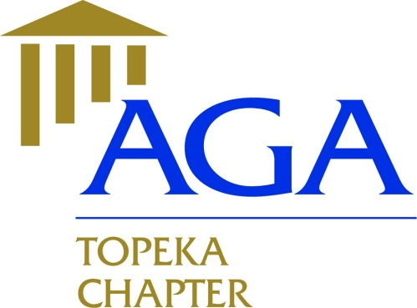

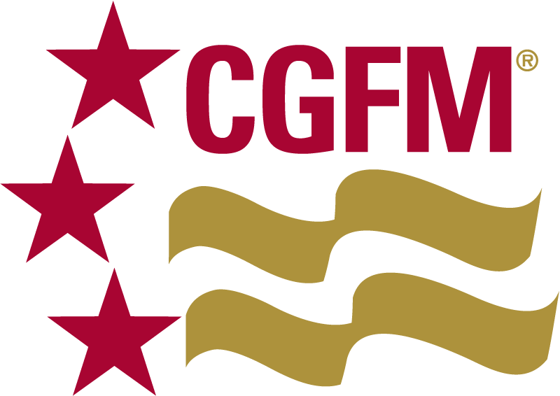

**Executive Committee Meeting Minutes Topeka Chapter**

**January 21, 2019**

**Members Present**:

2018 – 2019

President

Nicole Malott, CGFM

[nmalott@topeka.org](mailto:nmalott@topeka.org)

Treasurer

Dane Curtis, MBA

[Dane.Curtis@ks.gov](mailto:Dane.Curtis@ks.gov)

Secretary

Amy Bloom, MBA

[abloom@topeka.org](mailto:abloom@topeka.org)

Historian

Walter Darling, MPA, CPM

[Walt_Darling@hotmail.com](mailto:Walt_Darling@hotmail.com)

Social Media Coordinator

Hope Barber, MPA, CDFM, DoDFM2

[h_barber482@yahoo.com](mailto:h_barber482@yahoo.com)

President, Nicole Malott, CGFM

Secretary, Amy Bloom, MBA

Treasurer, Dane Curtis, MBA  
Hope Barber, MPA, CDFM, DoDFM2

**Meeting Location**: Margarita’s Jalisco @ 12:45PM

* Review/Approval of past meeting minutes from 12/17/18 meeting. Dane made a motion to approve; seconded by Amy. 4 Yea, 0 Nay.
* Financial Report from Dane: No Chapter PLS’s since Oct for revenues. Dane stated there is a Treasurer’s webinar at 1PM CST on Feb. 20 if anyone is interested in learning the ins/outs of the CEC treasurer role.
* Website/Newsletter: Feature new members in upcoming Newsletter. Need to include Hope and Dane intro.
* Educational Events: Speaker(s) from PPMG for Cybersecurity seminar in March and speaker(s) from KDOL for May seminar on Fraud/Data Analytics.
* SLMR Feb 9 in KC.
* LEAD Apr 25-27 in KC. Registrations due by March 1.
* N C of C Rep – Hope will check her schedule for conflicts. If Hope is unable, Nicole may serve. Update: 01/23/19: Hope unable to serve.
* Other Items for Discussion – Quizzes are free during federal government shutdown.
* Next Meeting – Feb 20th at Norseman Brewery at 5:15PM
* Dane made a motion to adjourn; seconded by Amy. Meeting adjourned at 1:47pm