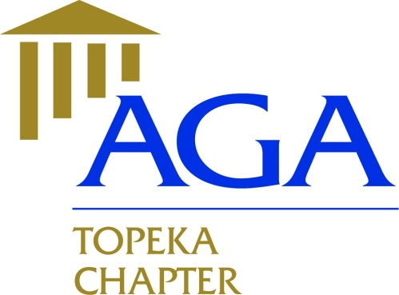

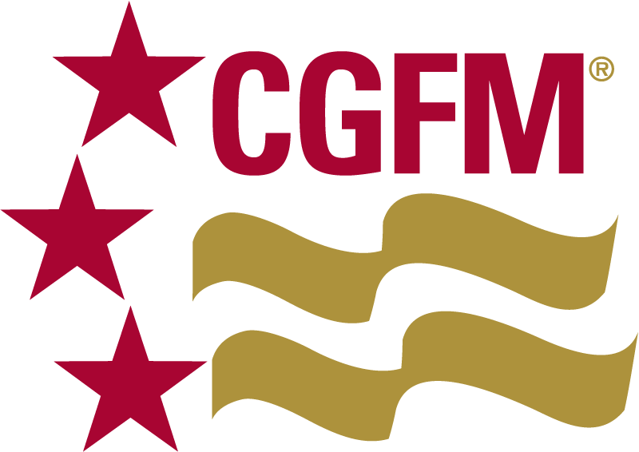

**Executive Committee Meeting Minutes Topeka Chapter**

**October 17, 2018**

**Members Present**:

2018 – 2019

President

Nicole Malott, CGFM

[nmalott@topeka.org](mailto:nmalott@topeka.org)

Treasurer

Dane Curtis, MBA

[Dane.Curtis@ks.gov](mailto:Dane.Curtis@ks.gov)

Secretary

Amy Bloom, MBA

[abloom@topeka.org](mailto:abloom@topeka.org)

Historian

Walter Darling, MPA, CPM

[Walt_Darling@hotmail.com](mailto:Walt_Darling@hotmail.com)

Social Media Coordinator

Hope Barber, MPA, CDFM, DoDFM2

[h_barber482@yahoo.com](mailto:h_barber482@yahoo.com)

President, Nicole Malott, CGFM

Secretary, Amy Bloom, MBA

Treasurer, Dane Curtis, MBA

**Meeting Location**: Norseman’s Brewery, 5:15PM

* Review and approval of 09/10/18 meeting; motion made by Amy to approve minutes with changes as specified, Dane 2nd the motion. Motion approved by all.
* Financials: No activity for September. October PLS financials will be available at the Nov 14th meeting.
* Website/Newsletter: Ideas for October Issue - New Members Recruitment, Upcoming Events, Membership Matters items. Amy will work on newsletter and get draft to Nicole by Oct 27.
* Educational Events: Dane has speaker in mind for the May PLS. Amy will check with Sheena for the Jan 9 PLS (Sheena Schmidt, City Grants Project Coordinator). Walt may have a speaker available for the March PLS.
* Community Service Drives: Toys4Tots at Oct/Dec PLS events, Collecting Toiletries for local charities.
* 990-N & Secretary of State Filings to be complete by respective deadlines.
* Ideas/Suggestions discussed for a social event in early 2019. A drawing was suggested for a spot at the 2019 PDT.
* The next meeting is scheduled for November 14 at 5:15pm at Norseman.
* Motion to adjourn by Amy, seconded by Dane. Adjourned at 5:55PM.