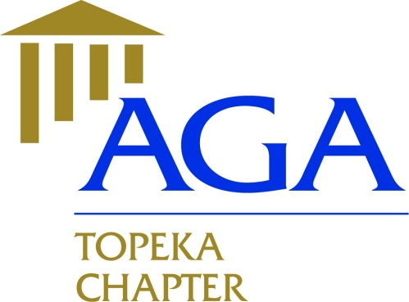

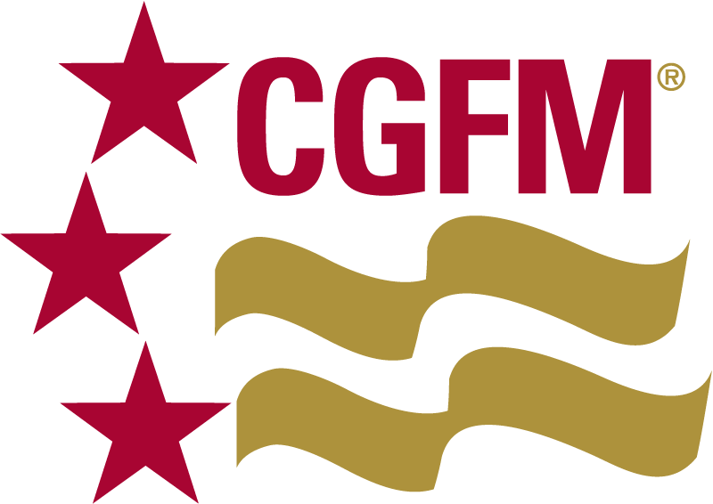

**Executive Committee Meeting Minutes Topeka Chapter**

**November 14, 2018**

**Members Present**:

2018 – 2019

President

Nicole Malott, CGFM

[nmalott@topeka.org](mailto:nmalott@topeka.org)

Treasurer

Dane Curtis, MBA

[Dane.Curtis@ks.gov](mailto:Dane.Curtis@ks.gov)

Secretary

Amy Bloom, MBA

[abloom@topeka.org](mailto:abloom@topeka.org)

Historian

Walter Darling, MPA, CPM

[Walt_Darling@hotmail.com](mailto:Walt_Darling@hotmail.com)

Social Media Coordinator

Hope Barber, MPA, CDFM, DoDFM2

[h_barber482@yahoo.com](mailto:h_barber482@yahoo.com)

President, Nicole Malott, CGFM

Secretary, Amy Bloom, MBA

Treasurer, Dane Curtis, MBA

**Meeting Location**: Norseman’s Brewery, 5:15PM

* Review and approval of 10/17/18 meeting; motion made by Amy to approve minutes with changes as specified, Dane 2nd the motion. Motion approved by all.
* Financials: October PLS revenue $205, $4.75 collected for Loose Change donation to Toys4Tots. $209.75 refund from PDT with $1720 expense for webinars for 2018/2019 education calendar.
* Website/Newsletter: Ideas for November Issue – SLMR info, Job Posting, Amy will work on newsletter and get draft to Nicole.
* Educational Events: 12/5/18 – Internal Controls (2 CPE), 1/9/19 – Grants Management, featuring live speaker Sheena Schmidt, City of Topeka Grants Program Administrator (3 CPE), 2/6/19 – GASB Update (2 CPE).
* 990-N & Secretary of State Filings completed.
* Ideas/Suggestions: Send job flyer to Hope for fb posting and add to Nov newsletter.
* The next meeting is scheduled for December 17th @ 5:15pm at Celtic Fox.
* Motion to adjourn by Amy, seconded by Nicole. Adjourned at 5:55PM.