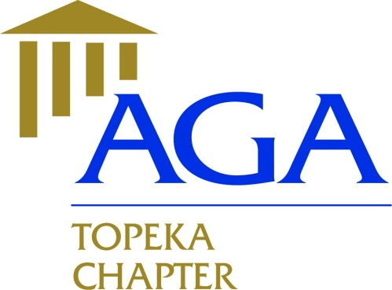

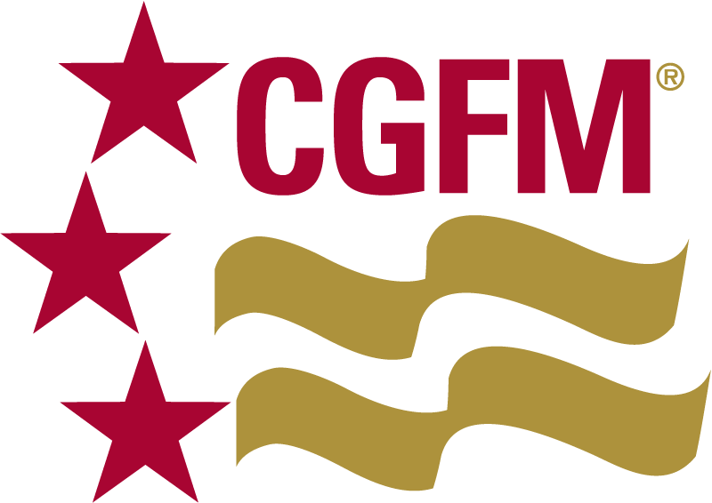

**Executive Committee Meeting Minutes Topeka Chapter**

**December 17, 2018**

**Members Present**:

2018 – 2019

President

Nicole Malott, CGFM

[nmalott@topeka.org](mailto:nmalott@topeka.org)

Treasurer

Dane Curtis, MBA

[Dane.Curtis@ks.gov](mailto:Dane.Curtis@ks.gov)

Secretary

Amy Bloom, MBA

[abloom@topeka.org](mailto:abloom@topeka.org)

Historian

Walter Darling, MPA, CPM

[Walt_Darling@hotmail.com](mailto:Walt_Darling@hotmail.com)

Social Media Coordinator

Hope Barber, MPA, CDFM, DoDFM2

[h_barber482@yahoo.com](mailto:h_barber482@yahoo.com)

President, Nicole Malott, CGFM

Secretary, Amy Bloom, MBA

Treasurer, Dane Curtis, MBA  
Walt Darling, MPA, CPM

**Meeting Location**: Celtic Fox, 5:15PM

* Review and approval of 11/14/18 meeting minutes will be done via email; Amy forgot to bring copies to the CEC meeting. Email Yea (4), Email Nay (0). Meeting minutes of 11/17/18 approved.
* Financials: November no activity, $40 for SOS filing (11/9), $8.12 interest earned on COD.
* Website/Newsletter: Ideas for November Issue – email list needs updated, several “bad” emails need deleted, Amy will work on newsletter and get draft to Nicole.
* Educational Events: 1/9/19 – Grants Management, featuring speaker Sheena Schmidt, City of Topeka Grants Program Administrator (3 CPE), 2/6/19 – GASB Update (2 CPE), 3/27/19 – Cybersecurity (4 CPE), 4/10/19 – Ethics (2 CPE), 5/15/19 – Fraud/Data Analytics (4 CPE), 6/12/19 – Leadership (2 CPE).
* SLMR – Feb 9, 2019 – New Governance – SLM (LEAD) Kansas City.
* The next meeting is scheduled for January 16, 2019 @ 5:15pm at Norseman Brewery.
* Motion to adjourn by Amy, seconded by Walt. Adjourned at 6:15PM.