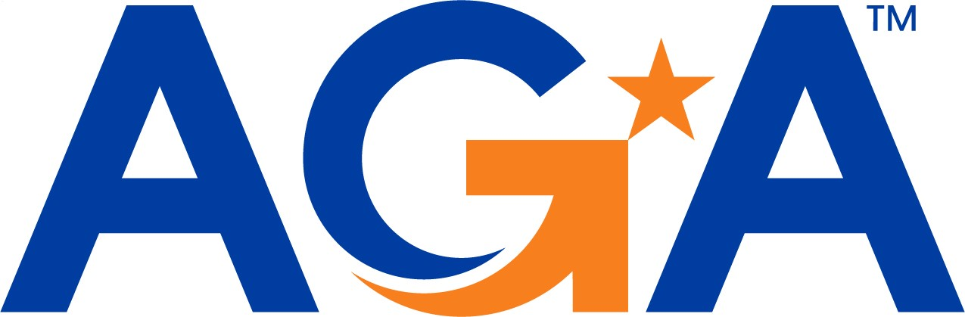

2025 AGA Corporate Partner Dinner Reservation Form

6:00 p.m. - 8:30 p.m.
Renaissance Arlington Capital View (2800 S. Potomac Ave, Arlington, VA)

- May 6, 2025 – Andrea Brandon, Deputy Assistant Secretary, U.S. Department of the Interior

- June 3, 2025 - TBA

PLEASE NOTE: Dinners are limited to 24 Corporate Partner representatives – 1 per organization. Cost is $190, which includes dinner, beverages and parking. Guarantees are given to the hotel the Wednesday before the dinner, so no cancellations after that time.

Please complete the following, as you would like it to appear on your name badge and the Attendee List:
Name:
Title:
Company:
Phone:
Email:
SPECIAL DIETARY NEEDS:
To expedite payment via your credit card, please complete: (NOTE: Your credit card will be charged the day after the event.)
CC # |  |  |  | CC TYPE:
CC EXPIRATION: |  |  | NAME ON CC:
CREDIT CARDS ACCEPTED: VISA, AMERICAN EXPRESS, MASTERCARD, DISCOVER

