CITIZEN-CENTRIC REPORT
Virginia Beach FY2025
A clear, four-page view of the community, services, finances and the road ahead

452,965  estimated population | 310 sq. mi.  city area | 38 miles  shoreline | 1963  city established

Our community and direction
◆ | Focused Action Plan  The FY24-25 plan aligned work and resources around Govern, Envision and Invigorate. Progress reports documented results for City Council.
✓ GOVERN  Effective, accountable government. | ◇ ENVISION  Plan for a changing community. | ★ INVIGORATE  Quality of life and economic vitality.

What city government provides
Public safety • education support • public works • parks and recreation • libraries • museums • housing • water, sewer, stormwater and waste services • planning and economic development
i | About this report  Selected information from the FY2025 Annual Comprehensive Financial Report. Dollar amounts are rounded. City review is required before publication.

PAGE 2
FY2025 Performance Highlights
Selected results and three-year performance trends
✓ GOVERN  ● AAA/Aaa bond ratings maintained  ● Real estate tax base: $82.0B  ● Clean FY2025 audit opinion  ● GFOA reporting recognition  $82B  REAL ESTATE TAX BASE | ◇ ENVISION  ● Windsor Woods Tide Gate operational  ● Bow Creek wetlands complete  ● 14.3M visitors in 2024  ● imagineVB 2040 adopted  $2.6B  TOURISM IMPACT | ★ INVIGORATE  ● Violent crime: 419, five-year low  ● Property crime: 6,735, five-year low  ● 293 parks and 7,400+ acres  ● 1,300+ trees planted  419 ▼  VIOLENT CRIMES | FIVE-YEAR LOW

Three-year performance trends
METRIC | FY2023 | FY2024 | FY2025 | TREND
Violent crime offenses | 591 | 449 | 419 | ▼ 5-year low
Real estate tax base | $69.2B | $76.2B | $82.0B | ▲ Growth
Meals tax revenue | $81.3M | $94.1M | $97.9M | ▲ 4.0%
Tourism visitors | 12.9M | 14.0M | 14.3M | ▲ Strong
Unemployment rate | 3.4% | 3.1% | 2.8% | ▼ Below U.S.
Hotel/lodging tax | $44.1M | $49.8M | $52.2M | ▲ 4.8%
★ | Recognition spotlight  Violent crime declined 29% from FY2023 to FY2025, while the City maintained AAA/Aaa bond ratings and financial-reporting recognition.
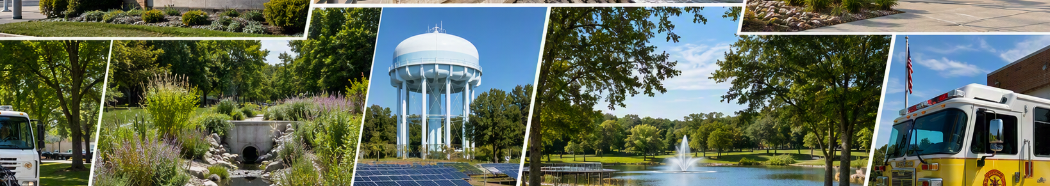

PAGE 3
FY2025 Financial Overview
Where the money comes from and where it goes
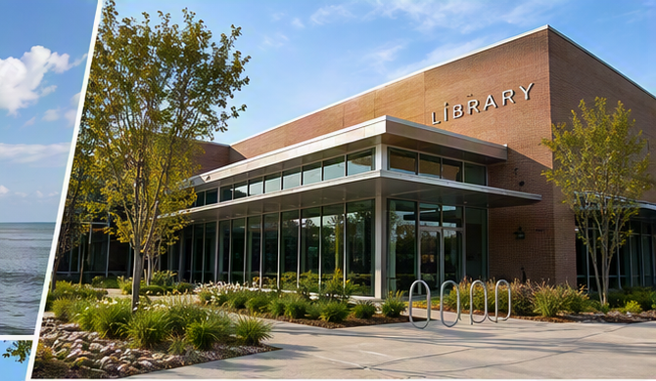
$ $2.168B  TOTAL REVENUE | → $1.969B  TOTAL EXPENSES | ▲ $199.0M  INCREASE IN NET POSITION
$ WHERE IT COMES FROM  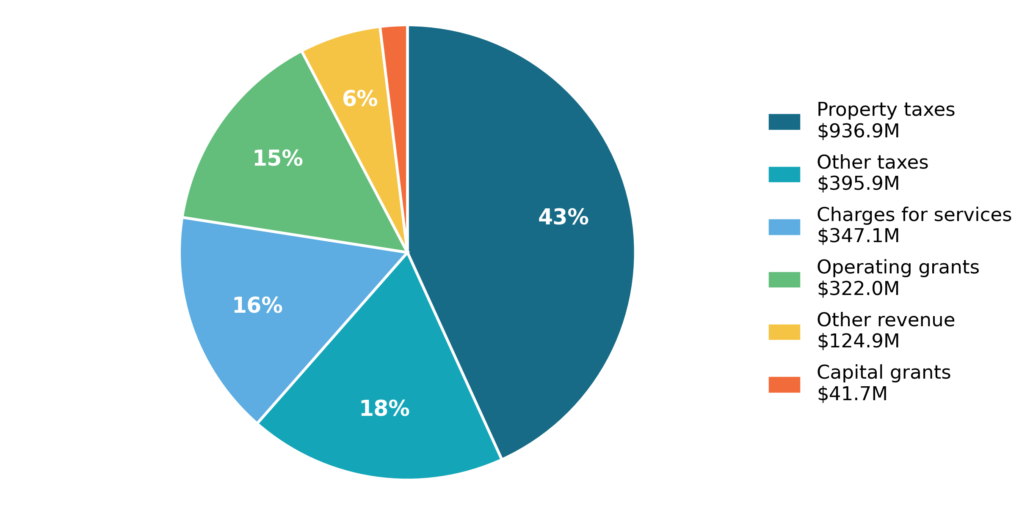  TOTAL REVENUE $2.168B | → WHERE IT GOES
   | SERVICE AREA | FY2025
  ◆ | Education | $465.3M
  ⚙ | Public Works | $199.1M
  ▣ | General Government | $175.2M
  ♥ | Human Services | $152.1M
  ≈ | Water & Sewer | $145.3M
  ★ | Police | $137.9M
  ▲ | Fire | $94.7M
  ⚖ | Judicial | $91.3M
  ♣ | Parks & Recreation | $68.3M
  ⌂ | Housing | $48.6M

Financial health indicators
✓ CLEAN AUDIT OPINION  Unmodified independent audit opinions. | ◆ STRONG FUND BALANCE  $173.6M unassigned; 11.5% policy measure.
★ AAA/Aaa BOND RATINGS  Top-tier ratings support fiscal strength. | ▲ GROWING NET POSITION  Up $199.0M to $4.692B.
Source: FY2025 ACFR MD&A, Table 2. Amounts are rounded; selected functions do not sum to total expenses.

PAGE 4
What’s Next?
Priorities, opportunities and challenges beyond FY2025
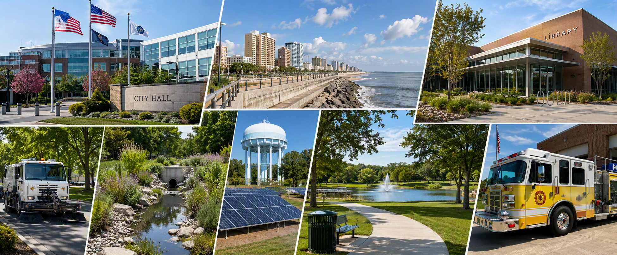

Looking forward
◇ | Next strategic plan  The FY26-27 Focused Action Plan was adopted by resolution on November 25, 2025.
$ | Economic and workforce conditions  A diverse tax base, defense activity, tourism and emerging industries remain important.
⌂ | Housing and affordability  Limited supply, rising costs and affordability require continued attention.
≈ | Infrastructure and resilience  Capital planning must balance maintenance, stormwater, flood protection and service needs.
▲ | Fiscal sustainability  Policies emphasize service continuity, disruption readiness, debt management and public understanding.

Tell us what you think
Questions to consider  Which services matter most?  Are the results and costs clear?  What should future reports explain better? | Contact and source  City of Virginia Beach Department of Finance  757-385-4681 | FinController@vbgov.com  finance.virginiabeach.gov/financials

